KEER2010, PARIS | MARCH 2-4 2010
INTERNATIONAL CONFERENCE ON KANSEI ENGINEERING AND EMOTION RESEARCH 2010
Modeling Customer Preferences for Commodities by Behavior Log Analysis with Ubiquitous Sensing
Modeling Customer Preferences for Commodities by Behavior Log Analysis with Ubiquitous Sensing
Naoki IMAMURAª, Hiroaki SUZUKI^{a,} Kenji NAGAYASUª, Akihiro OGINO^{b} and Toshikazu KATOª

ª Chuo University, Japan
^{b} Kyoto Sangyo University, Japan
abstract
We have been developing methods for modeling customer preferences for commodities. Here, we propose an “active sensing method” that observes unconscious and natural reactions to information dynamically and calmly provided by sensing system, as well as a “passive sensing method” that observes customers’ long-term behavior via logs taken by ubiquitous sensors. We evaluated these methods in terms of both their accuracy and the duration of modeling.
Keywords: Ubiquitous Sensing, Behavior log, Passive sensing method, Active sensing method
- Introduction
Amid increasingly diversifying customer preferences for goods and services in recent years, new marketing methods have been developed based on researching and observing the behavioral patterns of consumers at shops to estimate what kind of products they are interested in or planning to purchase [1]. Consumer behavior on commercial service websites as represented by Electronic Commerce (EC) sites is also attracting attention. More websites are offering recommended products by estimating the preference of each user from his/her behavioral logs (history logs of views and purchases on websites). In this study, we focused on consumer behavior at shops in order to find and distribute to consumers information of their preferences by understanding the preference of each consumer, and propose methods of estimating consumers’ preferences by observing their consumption patterns at a brick and mortar shop equipped with sensors and ubiquitous sensors such as Web cameras and RFIDs (hereinafter called the “smart shop”). For the methods of observing consumer behavior, we proposed a “passive sensing method,” which attempts to estimate the consumers’ preferences for products from their various natural behavioral logs as well as an “active sensing method,” which attempts to estimate consumers’ interests in products through their natural reactions and behavior including their unconscious reactions to various information offered to them dynamically. We developed consumer preference models by using these two proposed methods and evaluated their effectiveness.
This report describes the passive and active sensing methods and how to estimate consumer preferences including the development and the mechanism of the smart shop, evaluation experiments of each method and their results, views on the experiments and concludes with a summary.
- Methods of estimating the preferences of visiting customers
  - Sensors-based passive sensing method
In a general purchasing space, consumers consider purchasing products through behavior such as “looking” or “touching,” etc. while selecting products. And they tend to take more action for products of their interest to obtain more information about them. For these reasons, it is considered possible to estimate consumers’ preferences for products by observing such behavior [2] [3] [4]. For example, we can estimate that consumers who touch red dresses frequently in dress shops like red dresses or are considering purchasing a red dress.
The AIDA Model (Attention, Interest, Desire and Action) describes the general consumer purchase process [5]. In this research, we propose a “passive sensing method,” which attempts to estimate the consumers’ preferences for products by observing and collecting data on the natural behavior of consumers including their unconscious behavior by using sensors and based on the AIDA Model.
  - Active sensing method by using digital signage
In this paper, in addition to the passive sensing method, which observes natural actions and the behavior of consumers in shops as mentioned in the previous chapter, we also proposed an “active sensing method,” which attempts to estimate consumers’ preferences for the product information offered to them by displays, etc. by looking at their reactions to the information. Through the method, we observed consumers to see whether they looked at the advertisement information with interest or ignored it with no sign of interest. We assumed that the consumers liked the products if they showed behavior that could be construed as having interest in the product information offered to them while they did not like the products if they ignored the information.
As digital signage, an advertisement medium that shows video and information through displays by using a combination of display, telecommunication and digital technologies, is becoming very popular on the streets, we applied the active sensing method by offering the information to consumers through the digital signage installed at the shop.

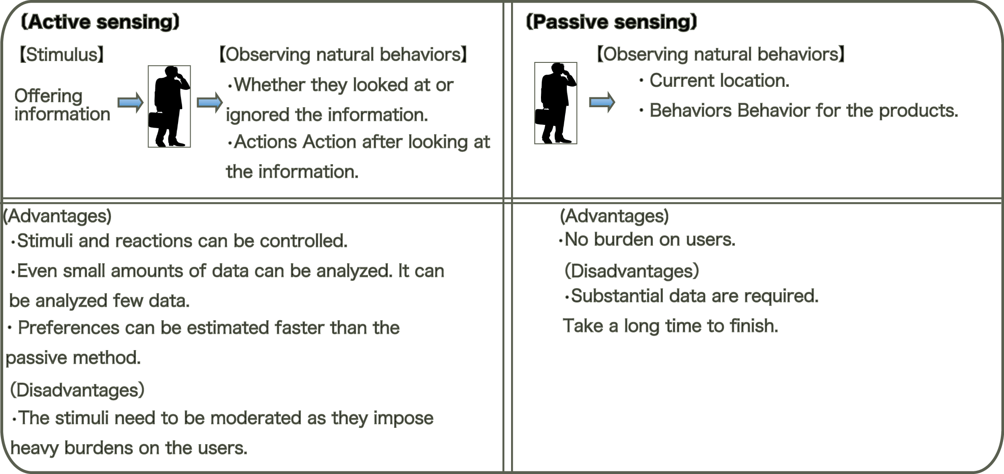

- Comparison between passive and active sensing methods
  - Comparison between passive and active sensing methods
The passive sensing method records data on consumer behavior at specific locations of the shop. It imposes almost no burden on consumers as we observe their natural behavior. However, we need to collect a lot of data to statistically estimate consumer preferences. The active sensing method, meanwhile, requires less data for the analysis because consumer preferences can be estimated based solely on information on consumer reactions to information offered to them as stimuli. However, observing consumer reactions imposes burdens on consumers and that the information available for analysis are limited to the reactions to only the information offered to consumers (Fig. 1).
- Method of estimating consumer preferences by the passive sensing method
  - Defining actions
This chapter describes a method of estimating consumer preferences by the passive sensing method.
We assumed, based on the purchasing process of the AIDA Model, that a consumer’s purchasing process starting from recognizing a product at a purchase space up to the purchase can be classified into the following three actions:
1. The consumer, after finding a product at a shop, perceives if he/she is interested in the product.
2. The consumer, after visually perceiving his/her interest in the product, touches the product to check the material or the price tag, etc.
3. The consumer takes up the product to obtain product information such as the size, shape and design, etc.

We called each of the above three actions “Look,” “Touch” and “Take,” respectively. “Look” represents the status of looking at a product, “Touch” represents the status of directly touching a product to confirm the texture and the price tag, etc. and “Take” represents the status of taking up a product to take a closer look or to make sure it meets his/her preference. We believe that these three actions conform to the AIDA Law of the purchasing process as they take into consideration the transition of actions from “Look” to “Touch” and “Take” as well as the level of interest (Fig. 2). However, it is difficult to determine the level of interest in a product just by a single action by a consumer as some consumers may touch or take up a product quite often while others may do so less frequently. For this reason, we assumed that we could estimate the consumer preferences for products by logging data on the types of actions and their numbers performed and, then, classifying them into purchasing patterns of consumers. In this research, we classified consumers into the following two purchasing patterns by observing consumers’ “Look,” “Touch” and “Take” actions and the number of each of the actions taken: “consumers who frequently take actions for products (hereinafter “product comparison pattern”)” and “consumers who take less actions for products (hereinafter “product attention pattern”).”
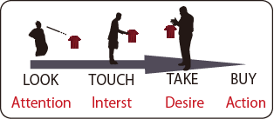

- Each action and AIDA Model
  - Quantification of “Look,” “Touch” and “Take” actions
We recorded the times and the number of each of the “Look,” “Touch” and “Take” actions by using ubiquitous sensors such as Web cameras and RFIDs. In this paper, we interpreted the “Look: the status of looking at a product” as “detecting a person in front of a product shelf by a sensor or the person observes someone else” and the “Look” is established when the sensor observes such a status. We interpreted the “Touch: the status of touching a product” as “a sensor observing changes in a product on a product shelf and the person observes someone else” and the “Touch” is established when the sensor observes such a status. And we interpreted the “Take: the status of taking up a product” as “a sensor keeping observing and reacting to changes in a product on a product shelf” and the “Take” is established when the sensor observes such a status. We quantified moves of persons, hands and products as observed by sensors.
  - Classifying shopping patterns by clustering
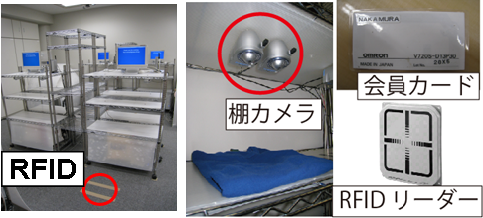
We assumed we could improve the accuracy of estimating preferences of the product attention pattern-based and product comparison pattern-based consumers by dividing the behavioral logs of a product into the product attention pattern and the product comparison pattern as the product attention pattern-based consumers generally tend to take actions only for products they like or they are interested in [2]. For the method of dividing into the two groups, we employed cluster analysis. We calculated a total of six average and dispersion results each for each of the consumer actions for multiple products. The number of “Look,” “Touch” and “Take” actions taken by a consumer for a product is represented by “x (Look),” “x (Touch)” and “x (Take),” respectively. By using the six variables and the number of consumers represented by “a,” we assumed that we could divide multiple consumers into the shopping patterns through the division method of the cluster analysis. In other word, we assumed that we could classify consumers into those with high and low number of actions by using the average and dispersion values of the number of each of the actions taken by consumers.

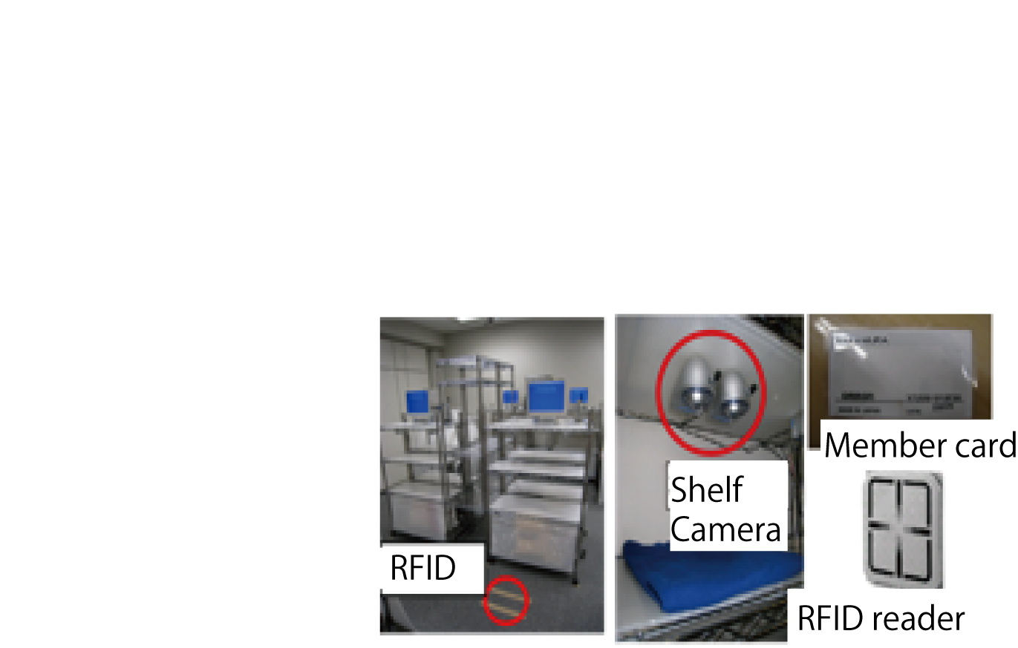

- Smart Shop System
  - Determining products of preference by discriminant analysis
We performed the discriminant analysis (Formula (1)) by using the level of interest (products of preference: Group No. 2, products of no preference: Group No. 1) as the response variable and the number of actions for each product (x (Look), x (Touch) and x (Take)) as the explanatory variable based on survey results after dividing consumer actions into the “product attention pattern” and the “product comparison pattern” by the cluster analysis. α, β, γ represent the weights of preference for “Take,” “Touch” and “Look,” respectively. γ represents Group No. 2 (products of preference) or Group No. 1 (products of no preference).
We verified the effectiveness of classifying into the shopping patterns by calculating the probability of correct and wrong hitting ratios of preferences based on the number of actions taken for each of the actions.
$y={αx}_{\text{Take}}+{βx}_{\text{Touch}}+{γx}_{\text{Look}}$ (1)
- Method of estimating consumer preferences by the active sensing method
This chapter describes a method of estimating consumer preferences by the active sensing method.
For the active sensing method, we observed consumer behavior of showing interest to as well as ignoring the product information offered to visiting customers while they were shopping. In this research, we used products available for sale at the shop as the recommended products and assumed consumers were interested in them when they went to the shelves of the products.
In order to verify the above assumption, we used a digital signage to dynamically offer information such as the images of products available for sale at the shop and the locations of the shelves of the products to visiting customers while shopping. We recorded the times when the information were offered and observed the traffic lines of the customers and determined that the customers liked the products when the traffic lines moved to the shelves of the products while they did not like the products when the traffic lines did not move or moved to shelves of the other products.
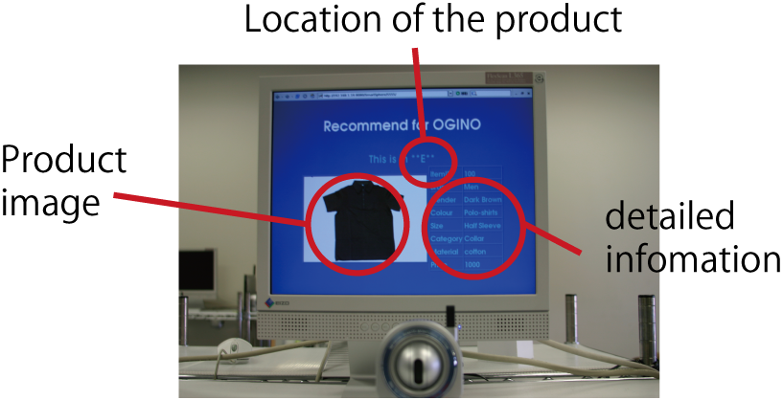
We surveyed, after shopping, whether the customers liked all the products on the shelves. Based on the conformity level achieved by comparing the level of interest based on survey results and the results of the active sensing method on the preferences, we verified the effectiveness of the active sensing method.

- Example of recommended product
- Developing smart shop
  - Building a brick and mortar purchase space equipped with ubiquitous sensors
In order to perform the passive and active sensing methods proposed in Chapters 2-4, we built a smart shop (Fig. 3), an observation and analysis system in the form of a shop space equipped with various sensors such as cameras and RFIDs to estimate the relationship between consumer actions and consumer preferences for products by observing consumer actions for products of “Look,” “Touch” and “Take” and by recording the times and the number of each of the actions.
For this experiment, we built, in a lab, a space used as a shop installed with 6 product shelves named A-F locations, Web cameras by Panasonic (BL-C31) at each shelf which are capable of taking pictures at a specific interval when any changes occur at each of the shelf locations and, then, stopping taking the pictures after a specific period of time and RFID readers by OMRON (V720 series) on the floors in front of the shelves (Fig. 4). The smart shop was designed in a way each of the subjects had to wear, for shopping, a pair of slippers embedded with an RFID card which included an ID code (a customer number) to identify the subject. The smart shop was also connected to all of the ubiquitous sensors at the shop so that we could analyze the data from the ubiquitous sensors and store logs on each action of the subjects.
  - Personal identification by RFID
We used RFIDs to identify the subjects to understand “who” took the action for the product at the smart shop. When consumers wearing slippers embedded with RFID tags came in front of product shelves, the RFID readers embedded on the floors in front of the product shelves identified the subjects. In this research, the RFID readers stored data on observed times, customer numbers and shelf locations in a database named “RFID” located in the smart shop when they observed the subjects’ RFID tags. The system could observe each action while multiple customers shopped at the smart shop all at the same time as each shelf recoded only once per subject.
  - Detecting the status of visiting customers looking at products or displays
In this research, we used the video observation technique to detect the action of looking at products by customers. The video observation allowed us to identify at which directions the customers’ faces were looking and record information about which products they looked at and for how long and, then, store these data on behavioral logs in a database named “Look.”

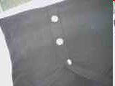



- Images observed by cameras at shelves
  - Detecting the status of visiting customers touching products
In this research, we used Web cameras installed at each product shelf to identify who “touched” which products while shopping. We used images of the status where products were not touched as background screens in order to find any differences with images taken while the subjects were touching the products (the status where the subjects’ hands were on the products) (Fig. 5). We logged, as the observation logs, in a database named “SHELF1” located at the smart shop any data with more than a certain level of differences. The data included the times when the images were taken and the locations of the shelves. We assumed that significant differences, if found, could mean the products were being touched. Then, we logged the behavioral logs in a database named “TOUCH” when the shelf locations and the observed times in the observation logs in the databases “RFID” and “SHELF1” matched.
In order to respond to changes in the environment, the background screens were updated when customers took up products and returned them to shelves untidy and such an untidy status continued for a certain period of time.
  - Detecting the status of subjects taking up products
We used other Web cameras installed at each product shelf to identify which products the subjects “took up” while shopping. We used images of shelves with no product on them as the background images and compared them with images taken while the subjects were taking up products (the status of no products on the shelves) to find the differences (Fig. 5). We logged, as the observation logs, in a database named “SHELF2” located at the smart shop any data with more than a certain level of differences between the images taken and the background screens. The data included the times when the images were taken and the locations of the shelves. We assumed that significant differences, if found, could mean the products were being taken up by the subjects. Then, we logged the behavioral logs in a database named “TAKE” when the shelf locations and the observed times in the observation logs in the databases “RFID” and “SHELF1” matched.
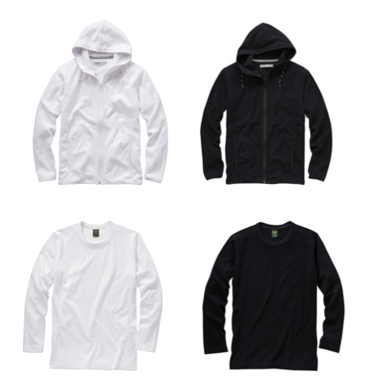
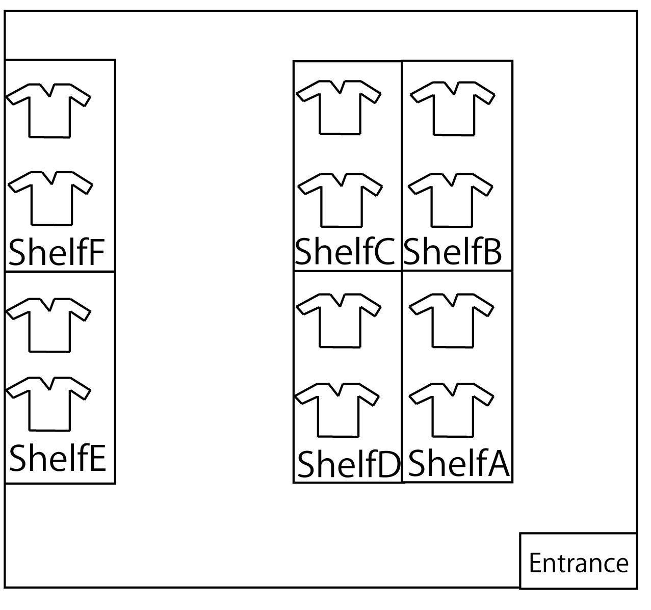
- Layout of smart shop
- Examples of products
  - Replacing displays of information on recommended products
For the experiment to verify the effectiveness of the active sensing method, we observed the subjects’ reactions to each of the recommended products by replacing, a couple of times, information on recommended products offered through displays installed on the product shelves at the smart shop while the subjects were shopping. We replaced information on recommended products every time the subjects moved from one shelf to another. We developed an algorithm for replacement, by using RFID readers embedded in the floors in front of the shelves, information on recommended products when RFID tags were detected at shelves different from the shelves where the tags were previously detected. The recommended products were selected at random from among 12 types each of parka shirts and long-sleeve T-shirts. The information displayed included the names of visiting customers whose IDs on their RFID tags matched those in the database, the images of recommended products, the names of the shelves of the recommended products as well as the materials, sizes, shapes and prices of the products. We also logged in the database named “RECOMMENDED” such information as the times when recommended products were replaced, locations of product shelves where RFIDs were observed and the RFID numbers.
  - Detecting the traffic lines of subjects by RFIDs
We used RFID readers installed in front of each shelf at the smart shop to detect the reactions of the subjects who looked at the recommended product information (to see if the subjects moved to the locations of the recommended products). We observed how the subjects moved around inside the smart shop on an hourly basis as the RFID readers recorded data on the times and the shelves when and where the subjects were observed. We compared the traffic lines and the logs of the recommended product information displayed in order to find out how the subjects moved to the shelves of the recommended products upon watching the displays.
- Evaluation experiments using passive and active sensing methods
  - Overview
We performed experiments to verify the effectiveness of the passive and active sensing methods described in Chapters 2-4.
  - Experiment 1: Experiment to evaluate the effectiveness of the passive sensing method
We performed an evaluation experiment by using the smart shop built for this research to verify the effectiveness of the methods proposed in Chapters 2 and 3. All of the 24 products used were T-shirts or polo shirts by UNIQLO (Fig. 7 on the left) including T-shirts with crewneck (hereinafter referred to as “C”) and V neck (hereinafter “V”) as well as polo shirts (hereinafter “P”) and border T-shirts, in 6 colors each (white, black, pink, yellow, light blue and blue). All of them were made of cotton and were “M” size. We selected from among these shirts two experimental sets with each set consisting of 12 shirts. The shirts were selected randomly but in a way such that the colors were not overlapped. The subjects were 13 men in their early 20’s.
We placed the first experimental set of shirts randomly on shelves A to F at the smart shop and observed actions taken by the subjects for each product after asking the subjects to purchase any of them (Fig. 6). We used another experimental set in the same manner. We asked the subjects, prior to the experiment, to select more than one shirt of their choice from among the experimental sets on each shelf at the smart shop so that they could actually look for and select products of their choice. The experiment ended when all the subjects finished selecting products of their choice. We offered for free at a later date the products the subjects selected so the subjects could actually select products of their choice.
We asked the subjects, 3 or more days after the experiment ended, to look directly at the 24 shirts used in the experiment and to evaluate each of them on the 5-grade scale (Table 2). We asked them to do so 3 days later because we needed the subjects to forget about their actions taken during the experiment so that we could survey the subjects’ real preferences. We did not perform the survey prior to the experiment because we did not want the subjects to see the products in advance.
- Average and dispersion of each action and results of grouping
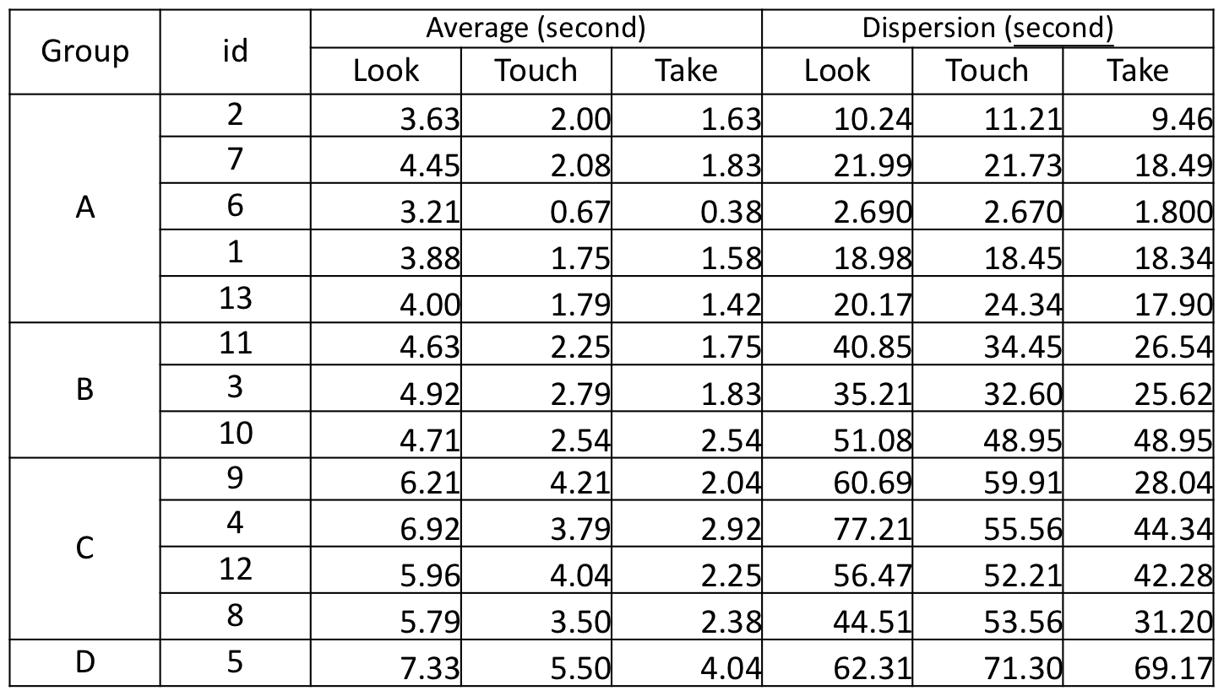

  - Experiment 1: Results
We calculated clustered average and dispersion times (in seconds) for each of the “Look,” “Touch” and “Take” actions taken at the time of shopping by the subjects at the smart shop. Table 1 shows the resulting values. We divided the results into 4 groups (A to D). Group A showed a strong tendency toward the “product attention pattern” while Group D showed a strong tendency toward the “product comparison pattern.”
After classifying the products graded 3 to 5 in the post-experiment survey by the subjects as products of their preference while those graded 1 or 2 as products of not their preference, we calculated, by discriminant analysis, the conformity level of estimating products of their preference and not their preference of each of the 13 subjects for 24 types of the shirt products. Table 3 shows the results. We classified the grade of 3 “Neither” as the products of their preference because we assumed the visiting customers would improve their evaluation and purchase the products depending on how the products were recommended.
  - Experiment 2: Experiment to evaluate the effectiveness of the active sensing method
We performed an evaluation experiment by using the smart shop to verify the effectiveness of the active sensing method proposed in Chapter 2.
We used parka shirts (P) or long-sleeve T-shirts (T) all by UNIQLO. We reduced the quantity of characteristics to the color and selected 12 colors (white, black, red, pink, yellow, light blue, blue, purple, green, yellow-green, gray and orange) for each. All of the 24 shirts were made of cotton of “M” size. The subjects were 13 men in their early 20’s as was the case in Experiment 1.
We placed the 12 colors of the parka shirts randomly on shelves A to F at the smart shop and observed the actions taken by the subjects for each product after asking the subjects to actually purchase one of them each. We used the long-sleeve T-shirts in the same manner. We asked the subjects, prior to the experiment, to select more than one shirt of their choice from among the experimental sets on each shelf at the smart shop so that they could actually look for and select products of their choice. We also asked them to move to the shelves of the recommended products displayed at the shop if they were interested in them after watching the displays or to continue shopping by ignoring them if they were not interested in them. We constantly observed the subjects’ moves by fixed video cameras installed in such a way as to not place much burden on the subjects. The experiment ended when all the subjects finished selecting products of their choice. We also asked the subjects, immediately after the experiment, to name all the recommended products to distinguish between the products the subjects ignored and those they simply did not notice the information. We asked the subjects, 3 or more days after the experiment ended, to evaluate each of the 24 shirts used in the experiment on the 5-grade scale.
- 5-grade scale evaluation of products in survey
Grade of preference
1 | Not at all
2 | Not much
3 | Neither
4 | Somewhat
5 | Very much
- Hitting the ratio of preference by subjects by passive sensing method
 | Estimation of “preference” | Estimation of “no preference”
All subjects | 46.1% | 90.7%
Ａgroup | 48.4% | 94.4%
Ｂgroup | 58.8% | 92.7%
Ｃgroup | 40.9% | 85.1%
Ｄgroup | 66.7% | 83.3%
- Table 4 Hitting the ratio of preference by subjects by active sensing method
 | Estimation of “preference” | Estimation of “no preference”
All subjects | 81.48% | 81.81%

  - Experiment 2: Results
The conformity level stood at 81.48% between the products that prompted the subjects to the product shelves after being displayed by the digital signage and the products graded 3, 4 and 5 in the post-experiment survey by the subjects. On the other hand, the conformity level stood at 81.81% between the products that did not prompt the subjects to the product shelves after being displayed by the digital signage and those graded 1 and 2 in the post-experiment survey by the subjects (Table 4).
- Views
  - Effectiveness of the passive sensing method
In these experiments, we estimated the consumer preferences by the passive and active sensing methods. The accuracy of estimating visiting customers’ preferences by the “passive sensing method” was around 50% while the accuracy of estimating products of no preference was as high as over 80%, suggesting that the customers rarely touched or took up products they visually did not like. It also suggests that products frequently touched or picked up by the customers did not necessarily mean they were products of their preference. These findings suggest that the actions of purchasing products include a process of comparing products and we believe we need to observe such action of comparison closely in order to improve the effectiveness of the passive sensing method.
  - Effectiveness of active sensing method
The results of the experiment on the active sensing method suggest that products of no preference are likely to be ignored even if they are recommended. However, the subjects may become interested in products for which they responded “Neither,” suggesting that such products may be purchased depending on how they are recommended.
The results of the 5-grade scale survey conducted after the active sensing experiment show the biggest number of subjects selected “Neither.” We assume this was because the subjects could not find products of their real preference because the quantity of characteristics was small as we limited the characteristics of the shirts to the color. Some subjects also suggested that the products displayed were different from those actually seen directly. The results suggest we need to come up with better ways to display recommended products (such as the materials, colors, etc.). In these experiments, we estimated and determined whether the subjects liked the products or not. Actually, however, consumers select products by taking into consideration various other factors such as price, color, material, size, etc. We believe we need to observe behavioral logs on the directions of the subjects’ faces and eyes, etc. in order to find out which factors are more important to the consumers.
  - Comparison in the effectiveness of passive and active sensing methods
The results suggest that we were able to estimate the preferences more accurately by the active sensing method than by the passive sensing method. However, the active sensing method can analyze only data on products whose information are offered as recommended products and are noticed by the subjects. The passive sensing method, meanwhile, can estimate multiple products of the consumers’ preferences at a single shopping. We believe we need to develop a method of analysis that combines the passive and active sensing methods.
- Summary
In this research, we estimated consumers’ interests in products by developing a smart shop to observe their actions for products through the passive and active sensing methods based on a simulation of a clothing shop.
In the passive sensing method, we estimated the consumers’ interests in products by classifying consumers’ purchasing actions into three actions (“Look,” “Touch” and “Take”) based on the AIDA Model and, then, observing and keeping the records of the three actions taken by the consumers. The results show that the conformity level for products estimated as those of preference stood at 66.7% at maximum while that for products estimated as those of no preference stood at 88.9%.
In the active sensing method, meanwhile, we performed an experiment by offering information on recommended products to consumers and estimated their interest or no interest based on their reactions to the recommended products. The results show that the conformity level for products estimated as those of preference stood at 81.48% while the level for products estimated as those of no preference stood at 81.81%.
These results suggest that the active sensing method is more accurate than the passive sensing method in estimating the preferences of consumers and, therefore, is more effective. However, as the active sensing method can estimate preferences for only products whose information is offered as recommended products, we need, in the future, to estimate consumer preferences through a combination of the passive and active sensing methods.
Acknowledgements
We are grateful to all the people at the Human Media Lab at Faculty of Science and Engineering, Chuo University, and Sensitivity Robotics Research Center for their continued earnest discussions on researches and cooperation with the experiments.
This experiment was supported partially by grants including a Grant-in-Aid for Scientific Research and Fundamental Research (S) “Robotics modeling of diversity of multiple KANSEI and situation understanding in real space” (Issue No. 19100004) and a Joint Research Grant, the Institute of Science and Engineering, Chuo University “Building symbiotic living space by and application to sensitivity services of sensitivity robotics environment,” etc.
references
1. Why We Buy: The Science of Shopping, by Paco Underhill, Hayakawa Publishing Corporation
2. Understanding consumer behavioral patterns by using ubiquitous interface, by Naoki Imamura, Kodai Okino, Japan Society of Kansei Engineering Paper Vol.8 No.3 Vol.8 No.3 (February 2009)
3. S. Sae-ueng, S. Pinyapong, A. Ogino, T. Kato;
Consumer friendly Shopping Assistance by Personal Behavior Log Analysis on Ubiquitous Shop Space, proceeding of 2nd IEEE Asia-Pacific Services Computer Conference; APSCCS2007, 496-503, (2007)
4. S. Sae-ueng, S. Pinyapong, A. Ogino, T. Kato;
Modeling personal preference using shopping behavior in ubiquitous information environment; proceeding of18th IEICE data engineering workshop /5th DBSJ annual meeting (DEWS2007), (2007)
5. http://ja.wikipedia.org/wiki/AIDMA
6. Designing real-world interface enabling the development of Kansei models and ubiquitous interactions, by Kazuhide Higuchi, Yoichi Watanabe, Seun Thomcat, Taro Katayama, Nobuyoshi Hayashi, Hiroyuki Nagase, Shunichi Kato, technical report of IEICE. Multimedia and virtual environment 103(745) pp.19-24 20040318

Corresponding author: 1-13-27 Kasuga, Bunkyo-ku, Tokyo 112-8551,Japan imamura@indsys.chuo-u.ac.jp

